**Couple’s Cycle***Infinity diagram designed by Scott R. Woolley Ph.D.*

**Pursuer**

Demand

Complain

Criticize

**Withdrawer**

Distance

Placate

Stonewall

**Behaviors**

Freezes with fear, disengages, turns to buddies, hobbies or work

**Perceptions**

“S/he has always been my safe haven but now is always mad. It’s not safe. I am never good enough for her/him.”

**Secondary Emotions**

What you see

Anger, frustration, numb,

Shuts down emotionally

**Primary Emotions**

What’s underneath

Sad, fearful, helpless,

lonely, unlovable, defective as a husband/wife/ and parent.

**Unmet needs**

“I want her/him to value me, trust that I am

capable of being strong and that I am needed”

**Behaviors**

Fights for connection, getting angry, controlling, criticizing, blaming.

**Perceptions**

“If s/he could see how lonely I am. I can’t trust him/her anymore-pulls away when I need him/her most”

**Secondary Emotions**

What you see

Anger, frustration, anxiety (fear)

**Primary Emotions**

What’s underneath

Fear of rejection, of being abandoned,

helpless, unlovable, unattractive

**Unmet needs**

“I need to feel loved and appreciated; I am

fearful that I am not enough”

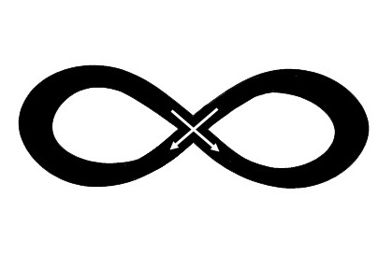

**Attachment Needs**

Need for Acceptance

Need for Closeness

Need for Understanding

Need to feel Important

Need to feel Loved

Need to feel Appreciated

Need your spouse reflect to you the good things about you.

**Attachment Fears**

Fear of being rejected

Fear of being abandoned

Fear of not measuring up, of being a failure

Fear of not being valued or accepted

Fear of being unlovable

Fear of being controlled

.